GCSE FRENCH
Why study French at GCSE?
People who study two (or more) languages can perform a host of uperhuman feats! They can order dinner in another country without getting broiled squid. They can make friends with people from different cultures and countries. They can also ask directions to the restroom and actually end up in the restroom.
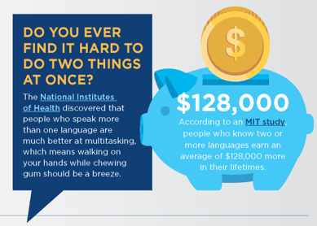
In our opinion, EVERYONE should learn another language! But don’t just listen to us… take
a closer look at the facts…

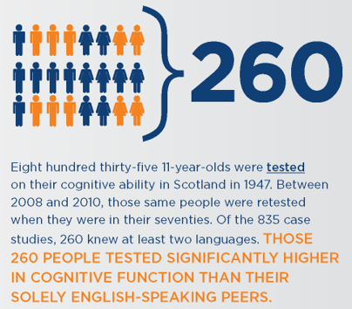

Studying French @ Drumglass High School
High Five
1. It’s Healthy! Learning a language is scientifically proven to be good for the brain | It activates the grey cells in your brain and has been proven to stave off Dementia | It makes you better at remembering and noticing things.
2. It could make you wealthy! A higher percentage of people who study foreign languages walk straight into good jobs | People who speak another language earn on average 20% more than people who don’t.
3. Gain more skills! When learning a foreign language, you learn a whole host of different transferable skills that can help you improve in other subjects | You can become a better communicator in English | Your social skills will improve | You will become more knowledgeable and tolerant of other cultures and differences within your own society.
4. Travel the World! Choosing French for GCSE at Drumglass High School will qualify you to go on quite a few school trips | On average our GCSE French pupils go on 3 school trips per year including: Queen’s Film Theatre in Belfast – Queen’s University Belfast - Disneyland Paris.
5. Enjoy yourself! A recent pupil survey at Drumglass High School showed that 100% of the pupils who studied French at GCSE enjoy studying the language.

GCSE FRENCH
What does the course entail?
At Drumglass High School we follow the GCSE French course and meet regularly with the course co-ordinators to help shape the specification and to support our teaching and learning in school.

Pupils will study a range of relevant language within three main topics.

- Students’ lives, families, homes, interests and holidays.
- Students’ lifestyles and attitudes to environmental, social and global issues.
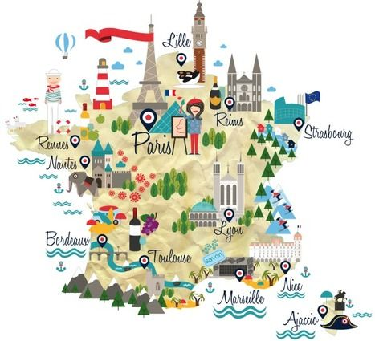
- Education and employment issues.

Assessment

Pupils are assessed in the four skills of:
- Listening
- Speaking
- Reading
- Writing

Listening Exam  Worth 25% of the final qualification.  Pupils will answer a range of questions in response to spoken French. | Speaking exam  Worth 25% of the final qualification.  Pupils will complete 2 role plays and participate in a general conversation with their teacher on two different topics.
Reading exam  Worth 25% of the final qualification.  Pupils will answer 12 questions in response to stimuli in French. | Writing exam  Worth 25% of the final qualification.  Pupils will answer four questions including translation and extended writing.
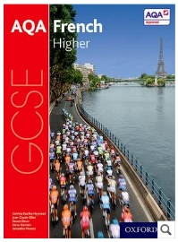
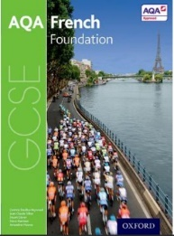
At Drumglass High School we use the following textbooks
in GCSE French:

OCN FRENCH
What does the course entail?
At Drumglass High School we also offer an French course as a more vocational route into languages. The course we follow is the OCN NI Level 2 Certificate in Modern Languages and this is the equivalent to a Grade B at GCSE level. Learners benefit from improved communication skills in both vocational and social context and may also expand cultural knowledge. In order to achieve the OCN NI Level 2 Certificate in Modern Languages (French), the learner is required to complete all 4 units for a total of 16 credits.

Pupils will study a range of relevant language within three main topics.

- Students’ lives, families, homes, interests and holidays.
- Students’ lifestyles and attitudes to environmental, social and global issues.
- Education and employment issues.

Assessment

Pupils are assessed in the four skills of:
- Listening
- Speaking
- Reading
- Writing

Listening Exam  Worth 25% of the final qualification.  Pupils will answer a range of questions in response to spoken French. | Speaking exam  Worth 25% of the final qualification.  Pupils will complete role plays and participate in a general conversation with their teacher on several different topics.
Reading exam  Worth 25% of the final qualification.  Pupils will answer four questions in response to stimuli in French. | Writing exam  Worth 25% of the final qualification.  Pupils will answer four questions including translation and extended writing.
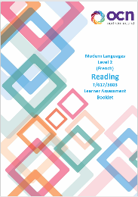
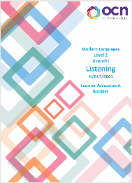
At Drumglass High School we use the Learner Assessment
Booklets recommended by OCN throughout the course.

